NAME –KRISHU BHATI
ROLLNO-25/SCA/BCAC/017

PROGRAM NO-1
#include <stdio.h>

#define MAX 100

int main() {
int arr[MAX], n = 0;
int choice, pos, value, i;

while(1) {
printf("\n----- ARRAY OPERATIONS -----\n");
printf("1. Insert\n");
printf("2. Delete\n");
printf("3. Display\n");
printf("4. Exit\n");
printf("Enter your choice: ");
scanf("%d", &choice);

switch(choice) {

case 1: // Insertion
if(n >= MAX) {
printf("Array is full! Cannot insert.\n");
break;
}

printf("Enter position (1 to %d): ", n + 1);
scanf("%d", &pos);

if(pos < 1 || pos > n + 1) {
printf("Invalid position!\n");
break;
}

printf("Enter value to insert: ");
scanf("%d", &value);

for(i = n; i >= pos; i--) {
arr[i] = arr[i - 1];
}

arr[pos - 1] = value;
n++;

printf("Element inserted successfully.\n");
break;

case 2: // Deletion
if(n == 0) {
printf("Array is empty! Cannot delete.\n");
break;
}

printf("Enter position (1 to %d): ", n);
scanf("%d", &pos);

if(pos < 1 || pos > n) {
printf("Invalid position!\n");
break;
}

for(i = pos - 1; i < n - 1; i++) {
arr[i] = arr[i + 1];
}

n--;
printf("Element deleted successfully.\n");
break;

case 3: // Display
if(n == 0) {
printf("Array is empty!\n");
} else {
printf("Array elements are:\n");
for(i = 0; i < n; i++) {
printf("%d ", arr[i]);
}
printf("\n");
}
break;

case 4: // Exit
printf("Exiting program...\n");
return 0;

default:
printf("Invalid choice! Try again.\n");
}
}

return 0;
}
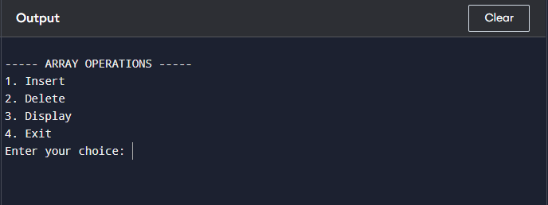

PROGRAM NO-2
#include <stdio.h>

int main() {
int A[10][10], B[10][10], C[10][10], T[10][10];
int r1, c1, r2, c2;
int i, j, k, choice;

printf("Enter rows and columns of Matrix A: ");
scanf("%d%d", &r1, &c1);

printf("Enter rows and columns of Matrix B: ");
scanf("%d%d", &r2, &c2);

printf("Enter elements of Matrix A:\n");
for(i = 0; i < r1; i++) {
for(j = 0; j < c1; j++) {
scanf("%d", &A[i][j]);
}
}

printf("Enter elements of Matrix B:\n");
for(i = 0; i < r2; i++) {
for(j = 0; j < c2; j++) {
scanf("%d", &B[i][j]);
}
}

printf("\n1. Sum\n2. Subtraction\n3. Product\n4. Transpose of Matrix A\n");
printf("Enter your choice: ");
scanf("%d", &choice);

switch(choice) {

case 1: // Sum
if(r1 == r2 && c1 == c2) {
for(i = 0; i < r1; i++) {
for(j = 0; j < c1; j++) {
C[i][j] = A[i][j] + B[i][j];
printf("%d ", C[i][j]);
}
printf("\n");
}
} else {
printf("Addition not possible!\n");
}
break;

case 2: // Subtraction
if(r1 == r2 && c1 == c2) {
for(i = 0; i < r1; i++) {
for(j = 0; j < c1; j++) {
C[i][j] = A[i][j] - B[i][j];
printf("%d ", C[i][j]);
}
printf("\n");
}
} else {
printf("Subtraction not possible!\n");
}
break;

case 3: // Product
if(c1 == r2) {
for(i = 0; i < r1; i++) {
for(j = 0; j < c2; j++) {
C[i][j] = 0;
for(k = 0; k < c1; k++) {
C[i][j] += A[i][k] * B[k][j];
}
printf("%d ", C[i][j]);
}
printf("\n");
}
} else {
printf("Multiplication not possible!\n");
}
break;

case 4: // Transpose of A
for(i = 0; i < r1; i++) {
for(j = 0; j < c1; j++) {
T[j][i] = A[i][j];
}
}

printf("Transpose of Matrix A:\n");
for(i = 0; i < c1; i++) {
for(j = 0; j < r1; j++) {
printf("%d ", T[i][j]);
}
printf("\n");
}
break;

default:
printf("Invalid choice!\n");
}

return 0;
}
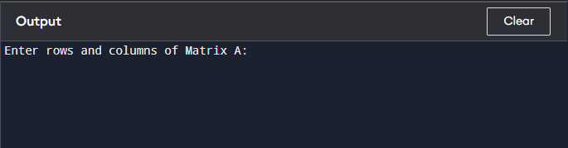

PROGRAM NO-3
#include <stdio.h>

#define MAX 100

/* ---------- Utility Function ---------- */
void display(int arr[], int n) {
for(int i = 0; i < n; i++)
printf("%d ", arr[i]);
printf("\n");
}

/* ---------- Bubble Sort ---------- */
void bubbleSort(int arr[], int n) {
for(int i = 0; i < n - 1; i++) {
for(int j = 0; j < n - i - 1; j++) {
if(arr[j] > arr[j + 1]) {
int temp = arr[j];
arr[j] = arr[j + 1];
arr[j + 1] = temp;
}
}
}
}

/* ---------- Insertion Sort ---------- */
void insertionSort(int arr[], int n) {
for(int i = 1; i < n; i++) {
int key = arr[i];
int j = i - 1;

while(j >= 0 && arr[j] > key) {
arr[j + 1] = arr[j];
j--;
}
arr[j + 1] = key;
}
}

/* ---------- Quick Sort ---------- */
int partition(int arr[], int low, int high) {
int pivot = arr[high];
int i = low - 1;

for(int j = low; j < high; j++) {
if(arr[j] < pivot) {
i++;
int temp = arr[i];
arr[i] = arr[j];
arr[j] = temp;
}
}

int temp = arr[i + 1];
arr[i + 1] = arr[high];
arr[high] = temp;

return i + 1;
}

void quickSort(int arr[], int low, int high) {
if(low < high) {
int pi = partition(arr, low, high);
quickSort(arr, low, pi - 1);
quickSort(arr, pi + 1, high);
}
}

/* ---------- Merge Sort ---------- */
void merge(int arr[], int l, int m, int r) {
int n1 = m - l + 1;
int n2 = r - m;

int L[50], R[50];

for(int i = 0; i < n1; i++)
L[i] = arr[l + i];
for(int j = 0; j < n2; j++)
R[j] = arr[m + 1 + j];

int i = 0, j = 0, k = l;

while(i < n1 && j < n2) {
if(L[i] <= R[j])
arr[k++] = L[i++];
else
arr[k++] = R[j++];
}

while(i < n1)
arr[k++] = L[i++];

while(j < n2)
arr[k++] = R[j++];
}

void mergeSort(int arr[], int l, int r) {
if(l < r) {
int m = (l + r) / 2;
mergeSort(arr, l, m);
mergeSort(arr, m + 1, r);
merge(arr, l, m, r);
}
}

/* ---------- Heap Sort ---------- */
void heapify(int arr[], int n, int i) {
int largest = i;
int left = 2*i + 1;
int right = 2*i + 2;

if(left < n && arr[left] > arr[largest])
largest = left;

if(right < n && arr[right] > arr[largest])
largest = right;

if(largest != i) {
int temp = arr[i];
arr[i] = arr[largest];
arr[largest] = temp;

heapify(arr, n, largest);
}
}

void heapSort(int arr[], int n) {
for(int i = n/2 - 1; i >= 0; i--)
heapify(arr, n, i);

for(int i = n - 1; i > 0; i--) {
int temp = arr[0];
arr[0] = arr[i];
arr[i] = temp;

heapify(arr, i, 0);
}
}

/* ---------- Main Function ---------- */
int main() {
int arr[MAX], n, choice;

printf("Enter number of elements: ");
scanf("%d", &n);

printf("Enter elements:\n");
for(int i = 0; i < n; i++)
scanf("%d", &arr[i]);

printf("\n1. Bubble Sort\n2. Insertion Sort\n3. Quick Sort\n4. Merge Sort\n5. Heap Sort\n");
printf("Enter your choice: ");
scanf("%d", &choice);

switch(choice) {
case 1:
bubbleSort(arr, n);
break;
case 2:
insertionSort(arr, n);
break;
case 3:
quickSort(arr, 0, n - 1);
break;
case 4:
mergeSort(arr, 0, n - 1);
break;
case 5:
heapSort(arr, n);
break;
default:
printf("Invalid choice!\n");
return 0;
}

printf("Sorted array:\n");
display(arr, n);

return 0;
}
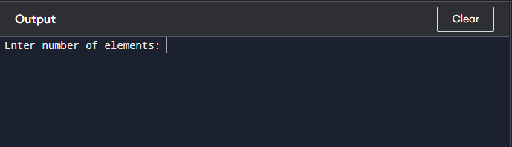

PROGRAM NO-4
#include <stdio.h>

/* -------- Linear Search -------- */
int linearSearch(int arr[], int n, int key) {
for(int i = 0; i < n; i++) {
if(arr[i] == key)
return i; // return index if found
}
return -1; // not found
}

/* -------- Binary Search -------- */
/* Array must be sorted */
int binarySearch(int arr[], int n, int key) {
int low = 0, high = n - 1, mid;

while(low <= high) {
mid = (low + high) / 2;

if(arr[mid] == key)
return mid;
else if(arr[mid] < key)
low = mid + 1;
else
high = mid - 1;
}
return -1; // not found
}

/* -------- Main Function -------- */
int main() {
int arr[100], n, key, choice, result;

printf("Enter number of elements: ");
scanf("%d", &n);

printf("Enter elements:\n");
for(int i = 0; i < n; i++) {
scanf("%d", &arr[i]);
}

printf("Enter element to search: ");
scanf("%d", &key);

printf("\n1. Linear Search\n2. Binary Search (Array must be sorted)\n");
printf("Enter your choice: ");
scanf("%d", &choice);

switch(choice) {
case 1:
result = linearSearch(arr, n, key);
break;

case 2:
result = binarySearch(arr, n, key);
break;

default:
printf("Invalid choice!\n");
return 0;
}

if(result != -1)
printf("Element found at position %d\n", result + 1);
else
printf("Element not found.\n");

return 0;
}
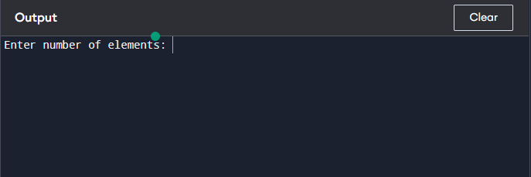

PROGRAM NO-5
#include <stdio.h>
#define MAX 5

/* ---------- STACK ---------- */
int stack[MAX], top = -1;

void push(int value) {
if(top == MAX - 1)
printf("Stack Overflow!\n");
else {
stack[++top] = value;
printf("Pushed %d into stack.\n", value);
}
}

void pop() {
if(top == -1)
printf("Stack Underflow!\n");
else
printf("Popped %d from stack.\n", stack[top--]);
}

void displayStack() {
if(top == -1)
printf("Stack is empty.\n");
else {
printf("Stack elements:\n");
for(int i = top; i >= 0; i--)
printf("%d\n", stack[i]);
}
}

/* ---------- LINEAR QUEUE ---------- */
int queue[MAX], front = -1, rear = -1;

void enqueue(int value) {
if(rear == MAX - 1)
printf("Queue Overflow!\n");
else {
if(front == -1)
front = 0;
queue[++rear] = value;
printf("Inserted %d into queue.\n", value);
}
}

void dequeue() {
if(front == -1 || front > rear)
printf("Queue Underflow!\n");
else
printf("Deleted %d from queue.\n", queue[front++]);
}

void displayQueue() {
if(front == -1 || front > rear)
printf("Queue is empty.\n");
else {
printf("Queue elements:\n");
for(int i = front; i <= rear; i++)
printf("%d ", queue[i]);
printf("\n");
}
}

/* ---------- CIRCULAR QUEUE ---------- */
int cqueue[MAX], cfront = -1, crear = -1;

void cenqueue(int value) {
if((cfront == 0 && crear == MAX - 1) || (crear + 1) % MAX == cfront)
printf("Circular Queue Overflow!\n");
else {
if(cfront == -1)
cfront = 0;
crear = (crear + 1) % MAX;
cqueue[crear] = value;
printf("Inserted %d into circular queue.\n", value);
}
}

void cdequeue() {
if(cfront == -1)
printf("Circular Queue Underflow!\n");
else {
printf("Deleted %d from circular queue.\n", cqueue[cfront]);
if(cfront == crear)
cfront = crear = -1;
else
cfront = (cfront + 1) % MAX;
}
}

void displayCQueue() {
if(cfront == -1)
printf("Circular Queue is empty.\n");
else {
printf("Circular Queue elements:\n");
int i = cfront;
while(1) {
printf("%d ", cqueue[i]);
if(i == crear)
break;
i = (i + 1) % MAX;
}
printf("\n");
}
}

/* ---------- MAIN MENU ---------- */
int main() {
int choice, value;

while(1) {
printf("\n1.Push (Stack)\n2.Pop (Stack)\n3.Display Stack\n");
printf("4.Enqueue (Queue)\n5.Dequeue (Queue)\n6.Display Queue\n");
printf("7.Enqueue (Circular Queue)\n8.Dequeue (Circular Queue)\n9.Display Circular Queue\n");
printf("10.Exit\nEnter choice: ");
scanf("%d", &choice);

switch(choice) {
case 1:
printf("Enter value: ");
scanf("%d", &value);
push(value);
break;
case 2:
pop();
break;
case 3:
displayStack();
break;
case 4:
printf("Enter value: ");
scanf("%d", &value);
enqueue(value);
break;
case 5:
dequeue();
break;
case 6:
displayQueue();
break;
case 7:
printf("Enter value: ");
scanf("%d", &value);
cenqueue(value);
break;
case 8:
cdequeue();
break;
case 9:
displayCQueue();
break;
case 10:
return 0;
default:
printf("Invalid choice!\n");
}
}

return 0;
}
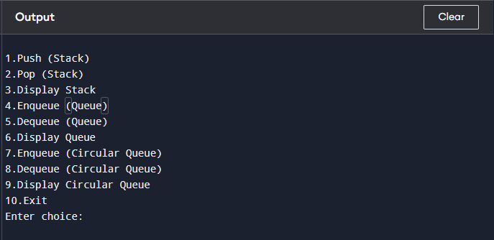

PROGRAM NO-6
#include <stdio.h>
#include <ctype.h>

#define MAX 50

int stack[MAX];
int top = -1;

/* Push element onto stack */
void push(int x)
{
stack[++top] = x;
}

/* Pop element from stack */
int pop()
{
return stack[top--];
}

int main()
{
char postfix[MAX];
int i, op1, op2, result;

printf("Enter postfix expression: ");
scanf("%s", postfix);

for (i = 0; postfix[i] != '\0'; i++)
{
/* If operand, push to stack */
if (isdigit(postfix[i]))
{
push(postfix[i] - '0');
}
else
{
/* Operator encountered */
op2 = pop();
op1 = pop();

switch (postfix[i])
{
case '+':
result = op1 + op2;
break;
case '-':
result = op1 - op2;
break;
case '*':
result = op1 * op2;
break;
case '/':
result = op1 / op2;
break;
default:
printf("Invalid operator\n");
return 0;
}
push(result);
}
}

printf("Result = %d\n", pop());
return 0;
}
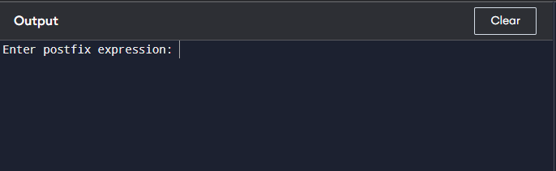

PROGRAM NO-7
#include <stdio.h>
#include <ctype.h>
#include <string.h>

#define MAX 100

char stack[MAX];
int top = -1;

/* Push function */
void push(char x)
{
stack[++top] = x;
}

/* Pop function */
char pop()
{
return stack[top--];
}

/* Check precedence */
int precedence(char op)
{
if (op == '^')
return 3;
else if (op == '*' || op == '/')
return 2;
else if (op == '+' || op == '-')
return 1;
else
return 0;
}

int main()
{
char infix[MAX], postfix[MAX];
int i, j = 0;

printf("Enter Infix Expression: ");
scanf("%s", infix);

for (i = 0; infix[i] != '\0'; i++)
{
/* If operand, add to postfix */
if (isalnum(infix[i]))
{
postfix[j++] = infix[i];
}
/* If '(', push to stack */
else if (infix[i] == '(')
{
push(infix[i]);
}
/* If ')', pop until '(' */
else if (infix[i] == ')')
{
while (stack[top] != '(')
{
postfix[j++] = pop();
}
pop(); // remove '('
}
/* If operator */
else
{
while (top != -1 &&
precedence(stack[top]) >= precedence(infix[i]))
{
postfix[j++] = pop();
}
push(infix[i]);
}
}

/* Pop remaining operators */
while (top != -1)
{
postfix[j++] = pop();
}

postfix[j] = '\0';

printf("Postfix Expression: %s\n", postfix);

return 0;
}
